**ABOUT US**

**◌ History**

* Established in 1994, as the first Organotin Stabilizer manufacturer in Indonesia (partnership with Morton International Inc.), PLANT 1
* Since 2006 expanded the business into Polymer Masterbatch & Compounds, PLANT 2
* Number of Employees : 114 people
* Subsidiary of PT Lautan Luas Tbk

**◌ Corporate Vision**

“To be the well known Company in PVC Heat Stabilizer and Plastic Masterbatch within ASIA with the commitment to increase asset of the company strategically”

Through :

**√** Producing high quality product based on customer needs

**√** Giving best services and cooperating with our valuable customers to achieve mutual benefits & partnership

**√** Rewarding all employees’ efforts with our motto:

**“To be effective and efficient in all Company aspects”**

**◌ Our Competitive Advantages**

**Product**

*Basic and Customize Product*

**Development**

*Wide Network of Material source*

*Expert and Experience R&D Team*

*Responsive development progress*

**Post-Sales Services**

*Strong CSR Team & Program*

*Partnership Cooperation*

**Support Services**

*Supporting Partners with advance experience & technology*

*State of the art Laboratory & QC Equipment*

*Integrated logistics*

**◌ Our Distribution Network**

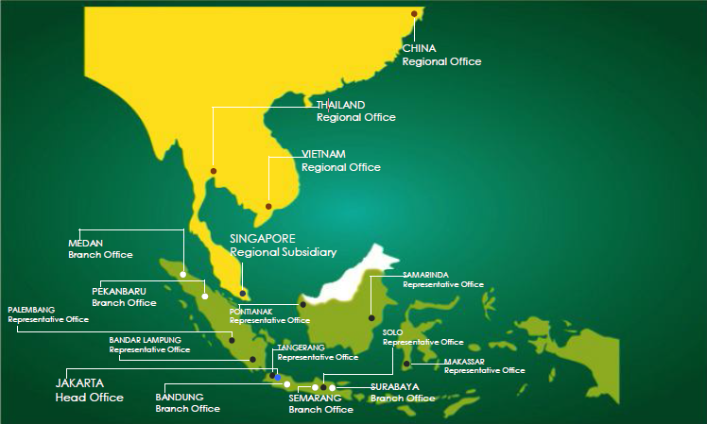

**◌ Certifications**

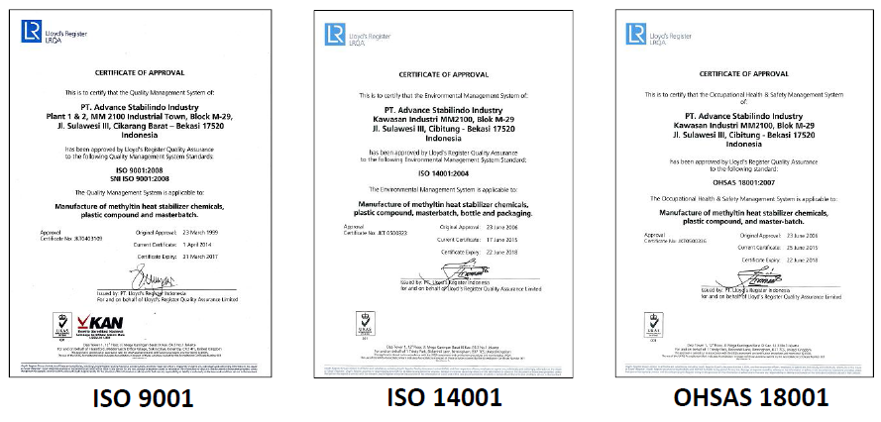

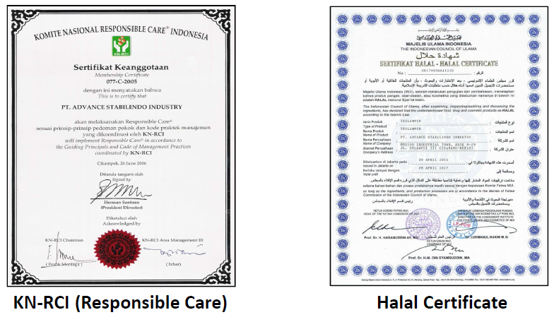

**PRODUCT & FACILITY**

◌ Product and Application

● PVC Stabilizers

● Advantages of Methyltin Mercaptide

● Extrusion Lamination

● BOPP, CPP and PE Film

● Thermoforming

● Injection Molding

● Blow Molding

◌ Product Facility

● Extrusion Lines

● Gravimetric Feeders

● Underwater Pelletizer

◌ R & D Facility

● Blown Film Machine

● Injection Molding Machine

● FPV Tester

● FT-IT

● FT-NIR

● Haze Meter

● CoF Tester

● Universal Testing Machine

● Melt Flow Indexer

● Izon Impact Strength

● Charpy Impact Strength

● Specific Gravity

● Moisture Tester

● Furnace